**Microsoft Azure Virtual Training Day: AI Fundamentals**

Online free training from MS 06/09/2021

Contents

Resources 1

Module1 – Introduction to AI 2

Artificial Intelligence 2

Demo 4

Responsible AI 5

Lab 6

Module 2 – Machine Learning 9

Regression 10

Classification 12

Clustering 15

Azure Machine Learning 16

Demo 17

Designer 19

Automated ML 23

Module 3 – Computer Vision & Cognitive Services 25

Computer Vision 25

Computer Vision Concepts 25

Cognitive Services 30

Demo 32

Module 4 – Natural Language Processing 35

NLP 35

Demo 37

Using Natural Language Processing Services 39

Module 5 – Conversational AI 47

Conversational AI in Azure 51

Demo – Create Bot 51

# Resources

**You can access a copy of the** [**presentation from the day here.**](https://eur02.safelinks.protection.outlook.com/?url=https%3A%2F%2Femails.microsoft.com%2FMTU3LUdRRS0zODIAAAF_hE6iZd1_GtlC9_AzzXpExT2KP0Mxa-m5uwyQnkY1RlRSLg0wzRR2-DDFdfbACYKFM-Dbeeo%3D&data=04%7C01%7Cliz.johnston%40ofgem.gov.uk%7C7d53e0e1d61246a8266208d977a46672%7C185562ad39bc48408e40be6216340c52%7C0%7C0%7C637672370241345128%7CUnknown%7CTWFpbGZsb3d8eyJWIjoiMC4wLjAwMDAiLCJQIjoiV2luMzIiLCJBTiI6Ik1haWwiLCJXVCI6Mn0%3D%7C1000&sdata=dsi79B0QZ4q9ezM4QUVWYP%2FGCMDqzy0O%2F661hvcx8Xc%3D&reserved=0)

<https://docs.microsoft.com/en-gb/learn/certifications/azure-ai-fundamentals/>

<https://docs.microsoft.com/en-gb/learn/certifications/exams/ai-900>

<https://docs.microsoft.com/en-gb/learn/certifications/azure-ai-engineer/>

<https://docs.microsoft.com/en-gb/learn/modules/use-automated-machine-learning/>

<https://docs.microsoft.com/en-gb/learn/paths/create-no-code-predictive-models-azure-machine-learning/>

<https://docs.microsoft.com/en-gb/learn/paths/explore-computer-vision-microsoft-azure/>

**Links used during the session:**

Learning Path <https://docs.microsoft.com/learn/paths/create-no-code-predictive-models-azure-machine-learning>/ Microsoft Certified: Azure AI Fundamentals <https://docs.microsoft.com/en-gb/learn/certifications/azure-ai-fundamentals>/ Sign up for the exam <https://docs.microsoft.com/en-gb/learn/certifications/exams/ai-900> Microsoft Certified: Azure AI Engineer Associate <https://docs.microsoft.com/en-gb/learn/certifications/azure-ai-engineer>/ Use automated machine learning in Azure Machine Learning <https://docs.microsoft.com/en-gb/learn/modules/use-automated-machine-learning>/ Create no-code predictive models with Azure Machine Learning <https://docs.microsoft.com/en-gb/learn/paths/create-no-code-predictive-models-azure-machine-learning>/ Explore computer vision in Microsoft Azure <https://docs.microsoft.com/en-gb/learn/paths/explore-computer-vision-microsoft-azure>/

# Module1 – Introduction to AI

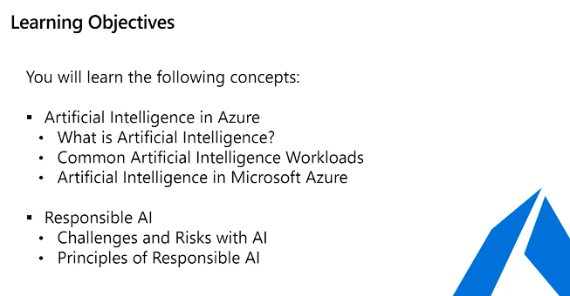

## Artificial Intelligence



Is science and engineering that make computers mimic human capabilities e.g. self driving cars

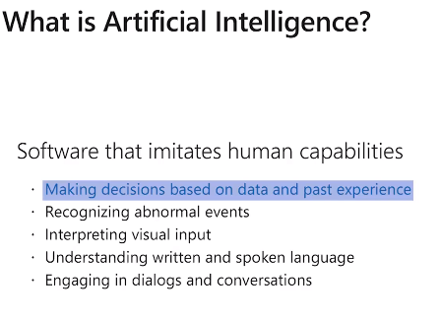

Human capabilities that can now be taken over by software

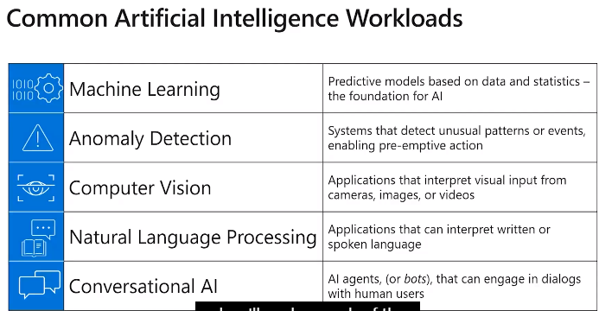

Machine Learning – bike rental shop. When temp high rent more bikes

Can use machine learning to predict how many bikes rent per day.

Anomaly detection – e.g. credit card fraud. E.G. you use your cc in Scotland then used in Australia. Could be fraud could be holiday

Computer Vision – face recognition, distance detection on cars, violence detection.

Natural Language Processing, voice detection, spell check, voice assistant.

Conversation AI. Bot AI conversation, submit claim, send photo, then uses Computer Vision to check the photo, use ML to predict cost, use AD to spot fraud detection.

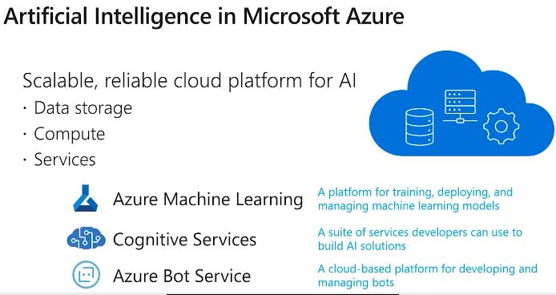

### Demo

Portal.azure.com

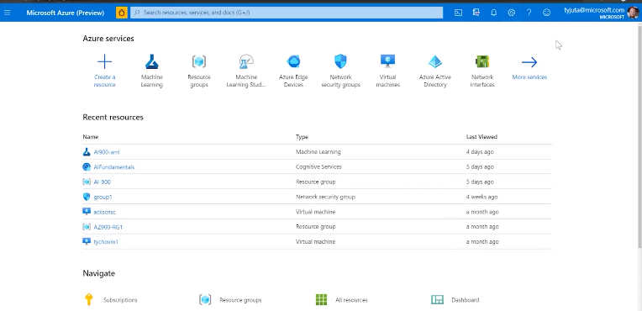

Can add favourites

And has some free training resources to start learning.

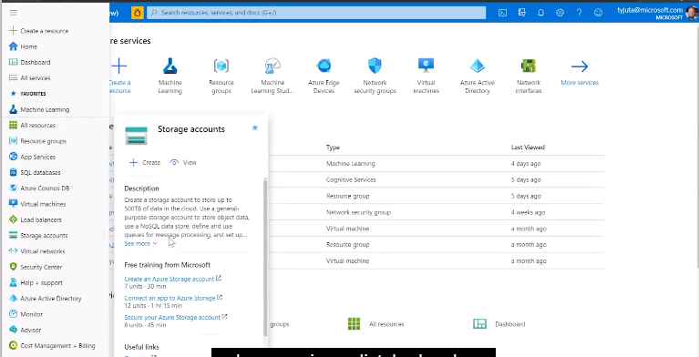

## Responsible AI

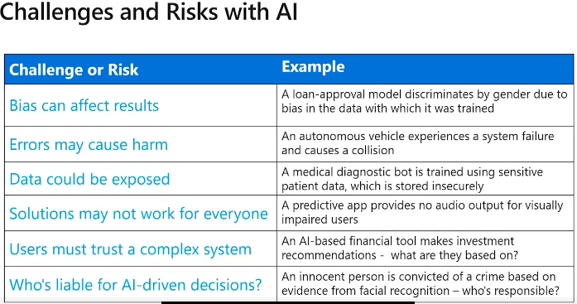

Bias

Apple Pies – model suggests best apple pie makers are left-handed. Is this true? Is this Bias?

Looking at the data saw that only had left hand were good and right hand were bad.

So check the data 1st so ML doesn’t make wrong predictions because of bias in the data.

Errors Cause Harm

Auto vehicles. Auto medical diseas/illness prediction then unnecessary operate.

Algorithm not perfect, makes mistakes!

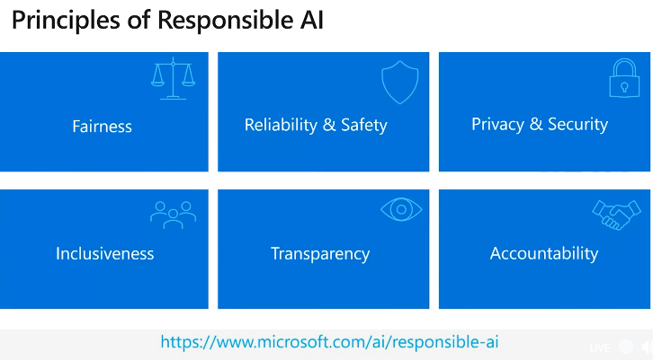

e.g.

* loan approval from bank. Must not have bias so treat everyone fairly – no bias for gender, race, etc.
* Auto vehicle must be reliable or risk to human life.
* Data must be secure – for testing and in production
* All AI should include all – regardless or physical, gender, etc
* Transparency – should be obvious what it’s doing, etc
* Accountability – people must be responsible! If autonomus vehicle has accident who is responsible?!
* Must develop in ethical and legal principle!

### Lab

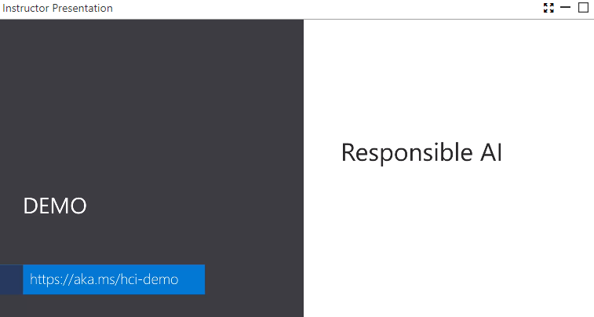

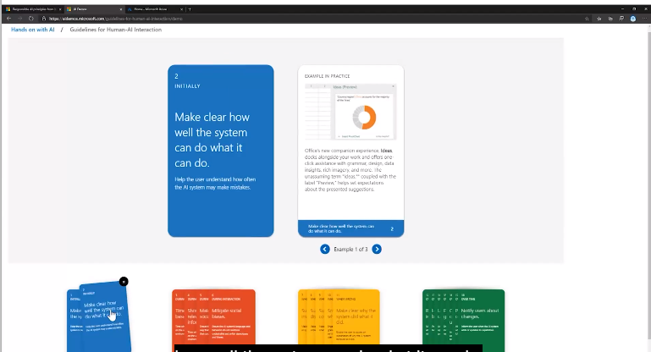

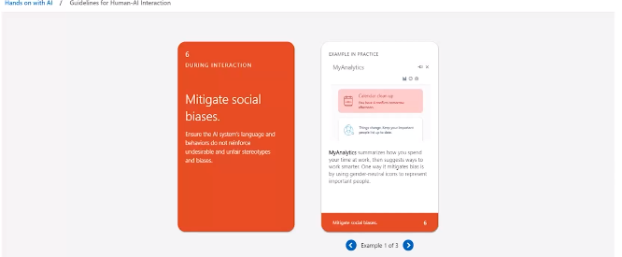

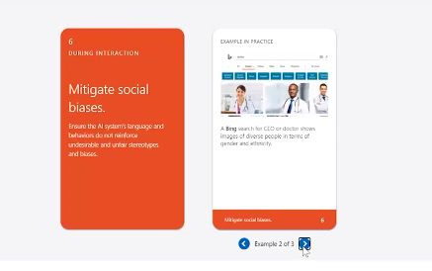

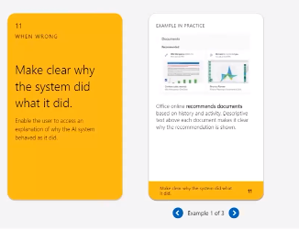

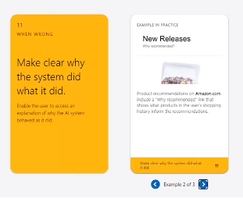

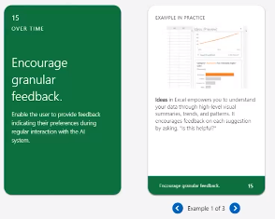

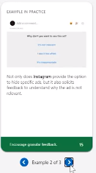

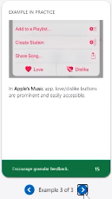

Recommend going through cards at home.

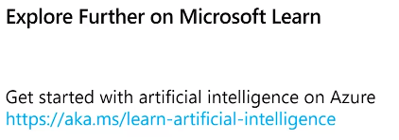

27 mins long, gives you practice.

# Module 2 – Machine Learning

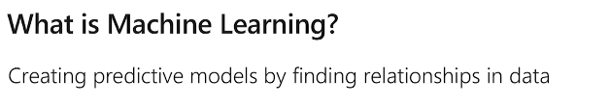

Botanist – lots of flowers, create labels = sample data

Model between features and labels

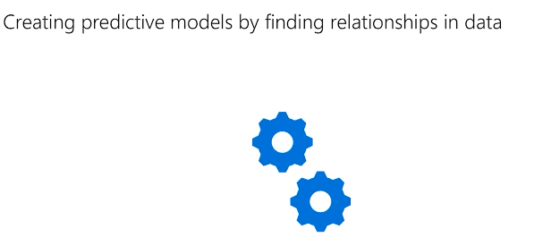

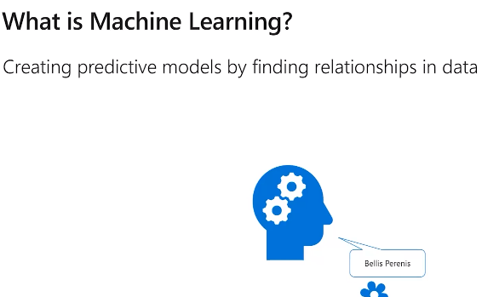

## Regression

Predict a numeric value

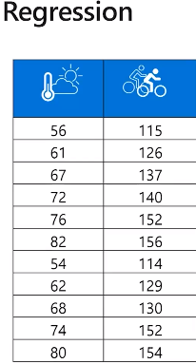

Bike Retals = Y

Features = X

Split data into training and validation

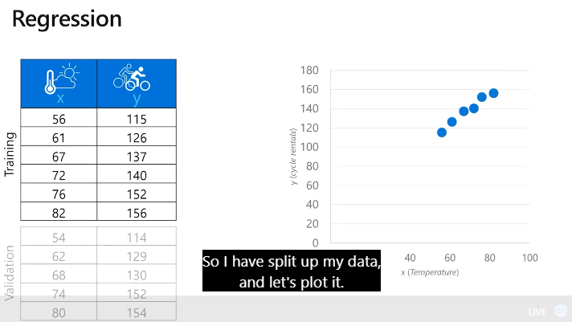

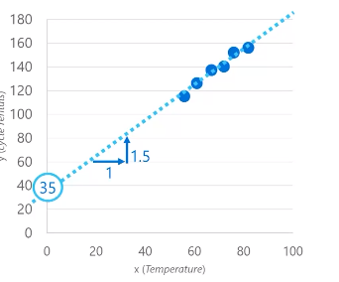

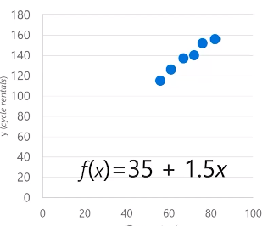

Test with the validation data = y hat

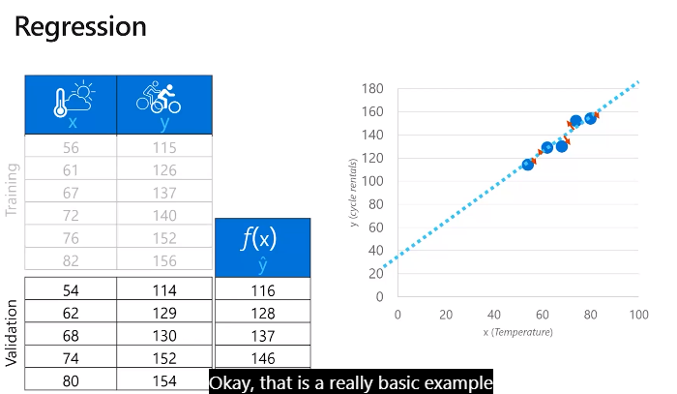

Can work out the accuracy of the model.

## Classification

Diabetes Detection

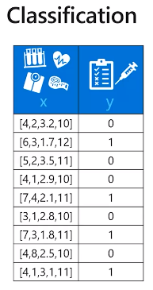

Probability – 1 = diabetes and 0 not diabetes

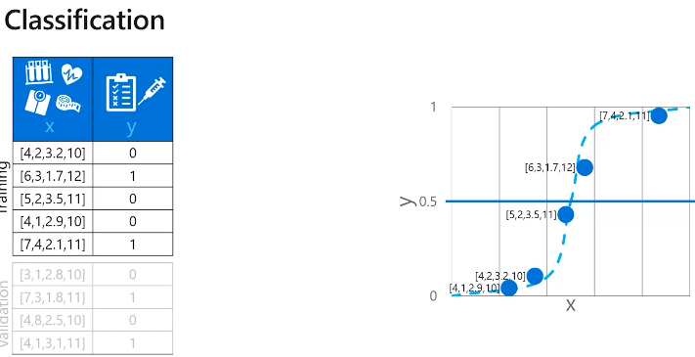

Threshold in the middle difficult to tell if diabetes

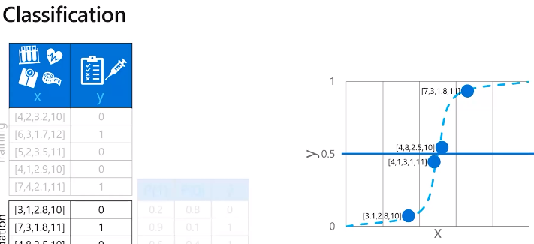

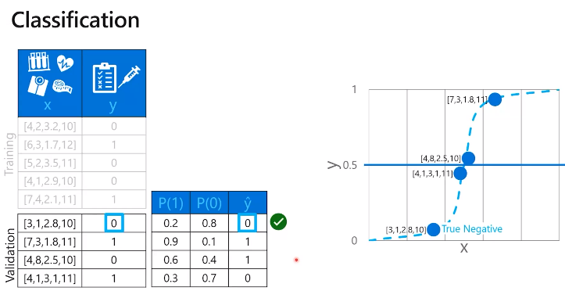

Top 2 are true positives

3rd is false positive

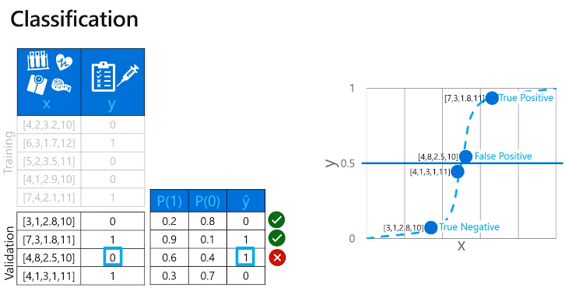

4th is false negative

Need lots of data

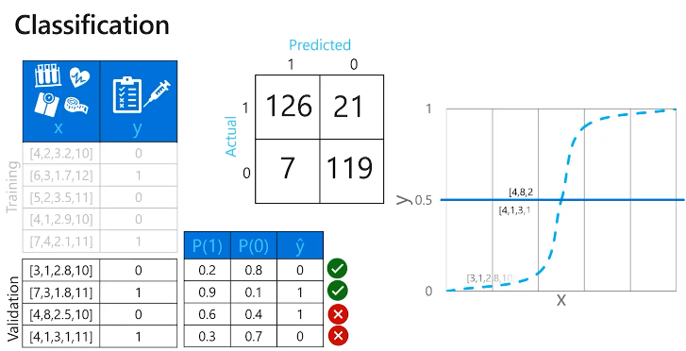

Can calculate accuracy

Accuracy 90%

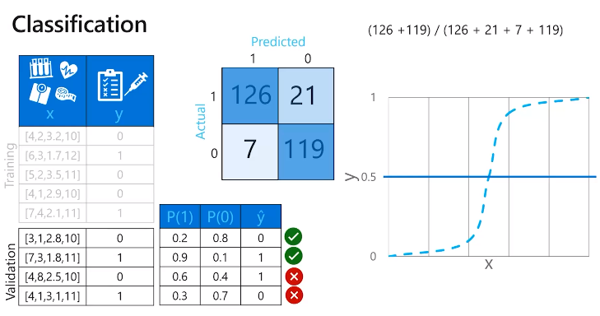

## Clustering

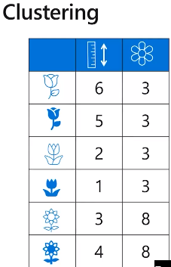

No labels to help identify flowers

Find 3 groups = K

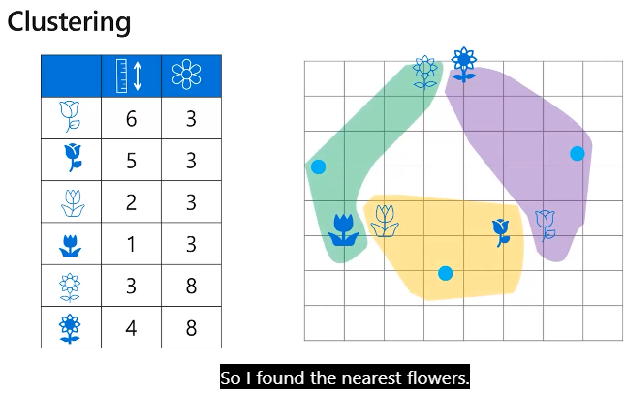

Centrist in centre based on mean distance

## Azure Machine Learning

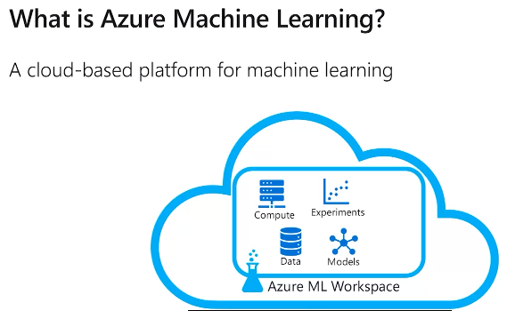

History of experiments so can track what ou did

Can store modules ready to publish

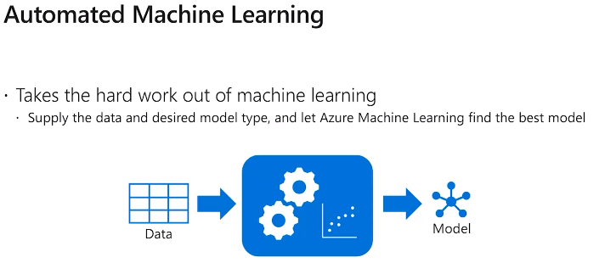

When automate the ML function does and gives best model back.

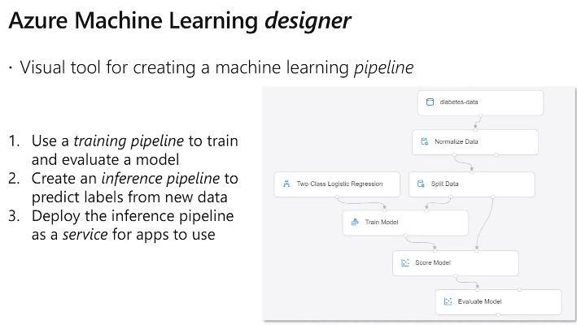

### Demo

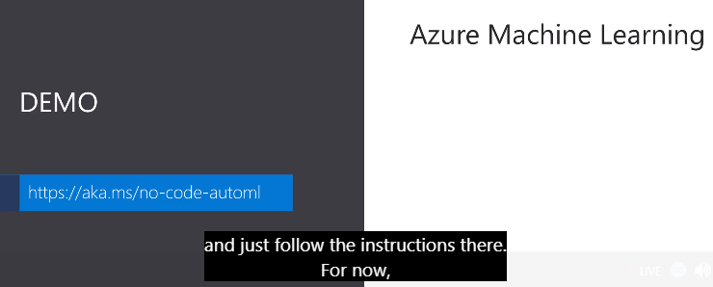

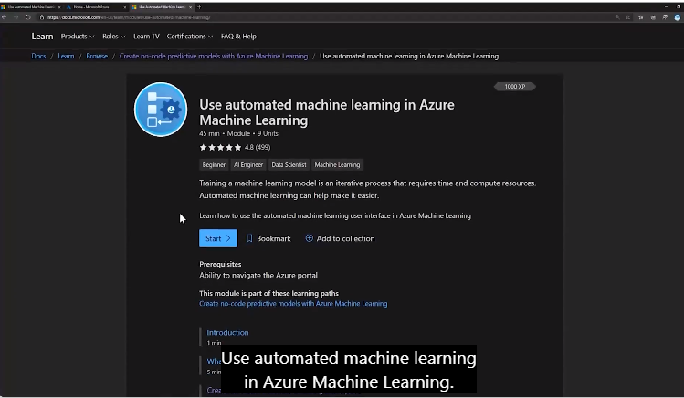

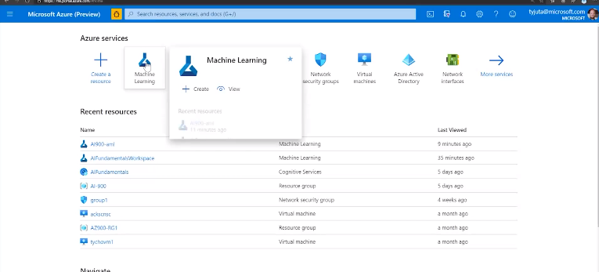

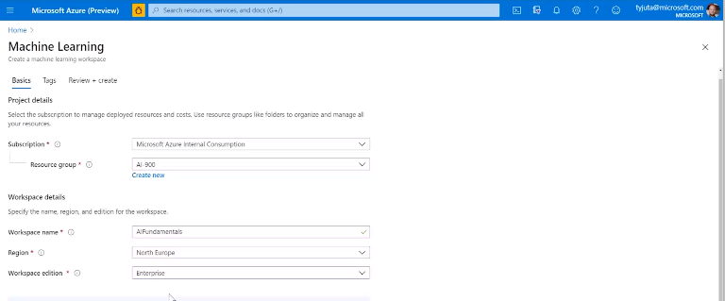

Once created can then access from ML button

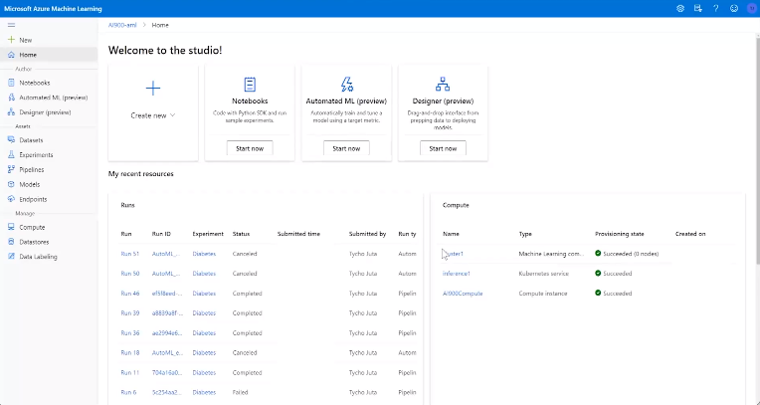

Data Labelling

Data Sources incl local data resources

Compute

Models – stores models and versions

End point – when you’re deploying

Experiments – e.g. diabetes

Can view data

Check/normalise/correct/clean data before ingest.

Feature engineering create other columns from existing data e.g. join columns, add date, season, etc

Can select which features are important

### Designer

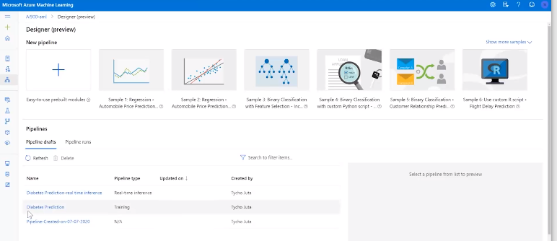

On left modules want to use – drag onto screen

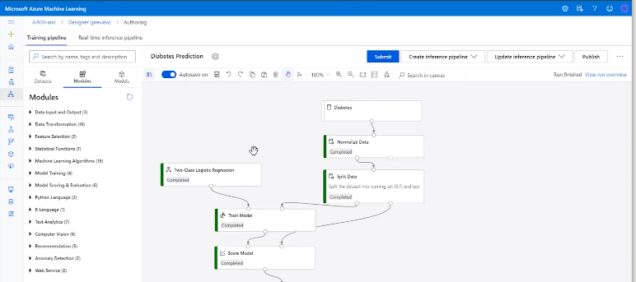

Can click on each model to see what it is and edit if required

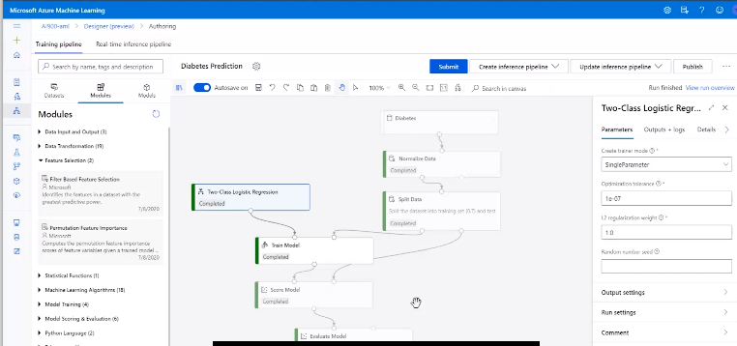

Evaluate Model

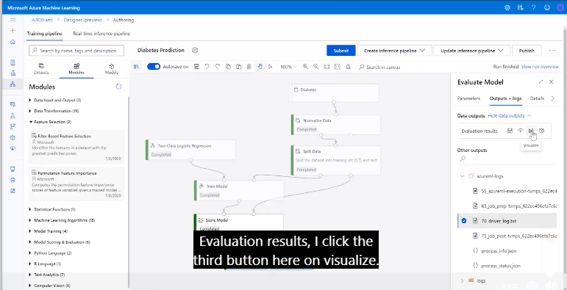

Lots of false negatives – 86

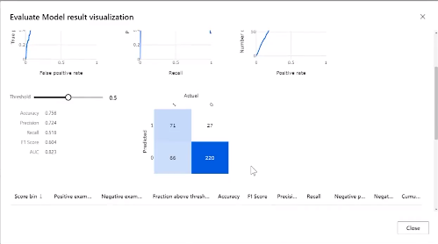

Can change threshold from 0.5 using slider on LHS

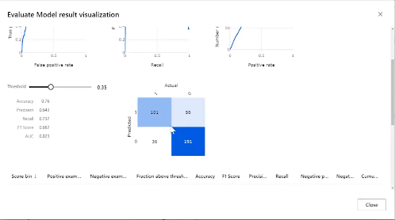

Try doing this for pregnancy tests!

When happy can create interference pipeline

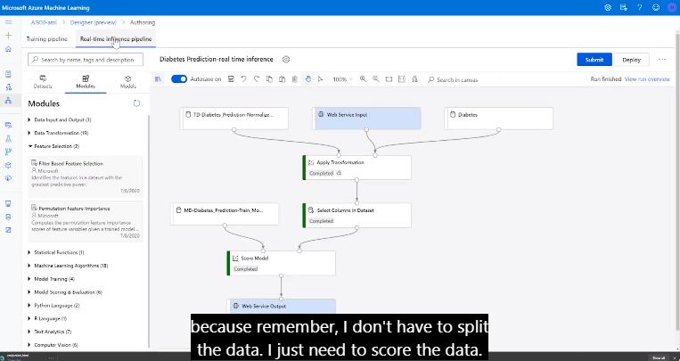

Can publish and then an endpoint becomes available

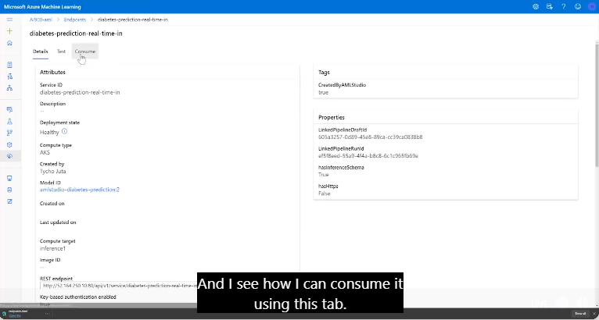

Click on test to see and change some values

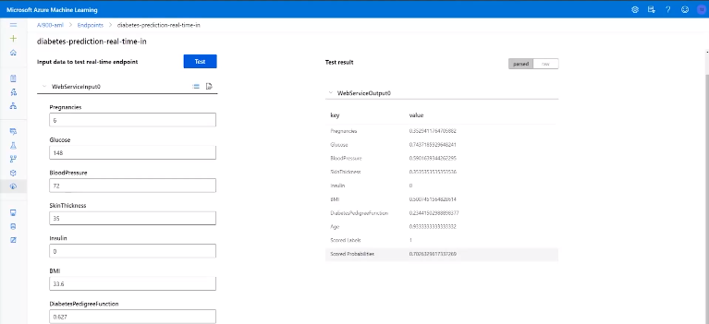

### Automated ML

Without creating the pipelines can run and see the best outcomes it can find.

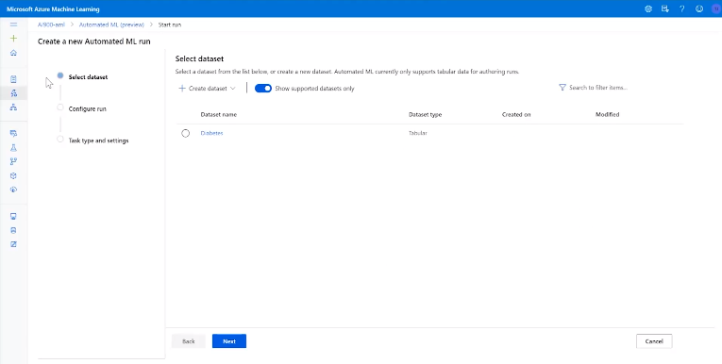

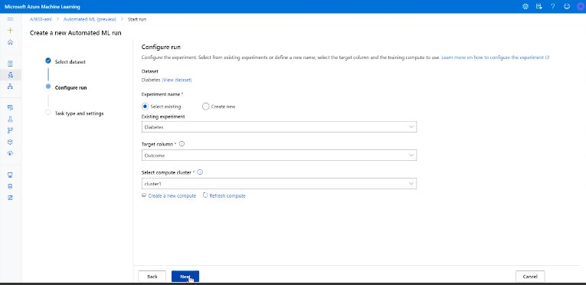

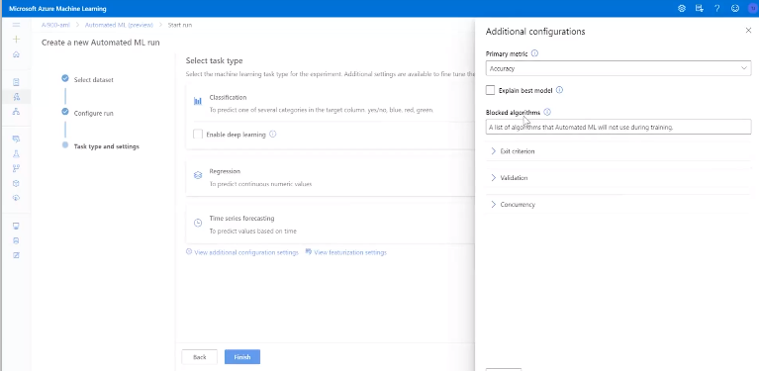

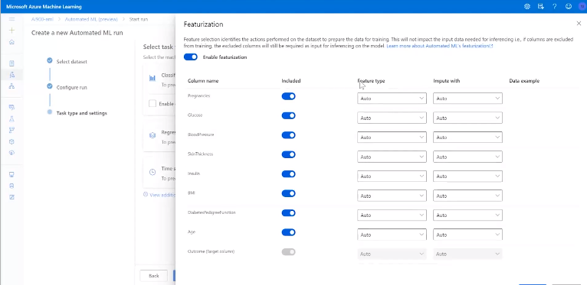

When click finish it will iterate all algorithms and it will suggest models

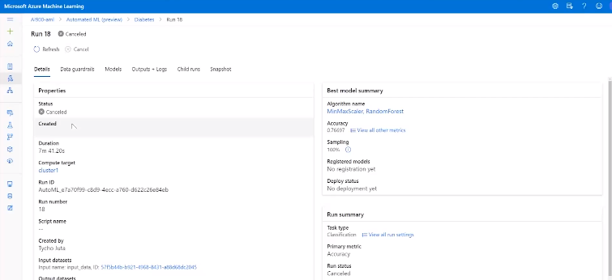

# Module 3 – Computer Vision & Cognitive Services

## Computer Vision

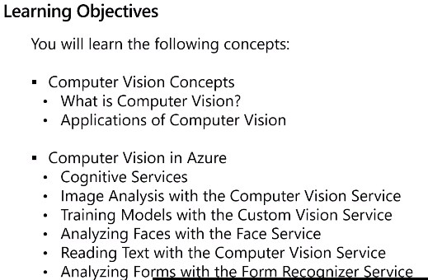

### Computer Vision Concepts

Array of colour pixels 0 – 255 – RGB

Detect pixels and patterns

Scan group of small squares

Algorithm finds lines, circles, etc

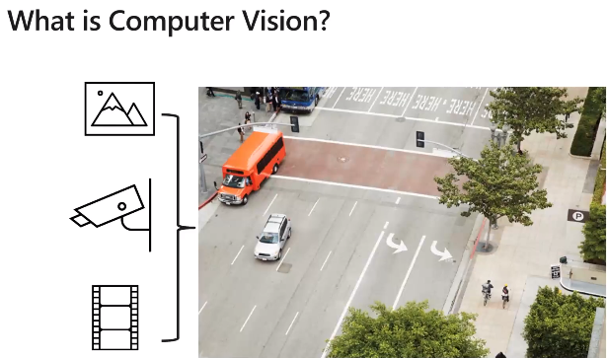

Uses classification to apply label to picture

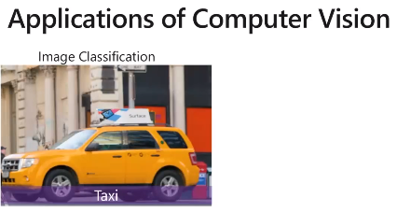

Object detection

Train model to detect objects

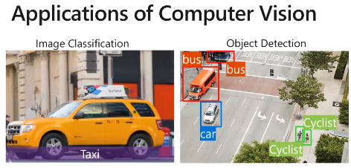

Segmantic segmentations – advanced uses pixels in the module they belong to

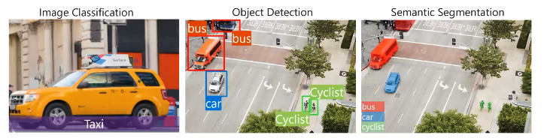

Image Analysis, Face Detection and Recognition & Optical Character Recognition

Add text and context

Face recog

Optical Character Recognition extracts charaters from image

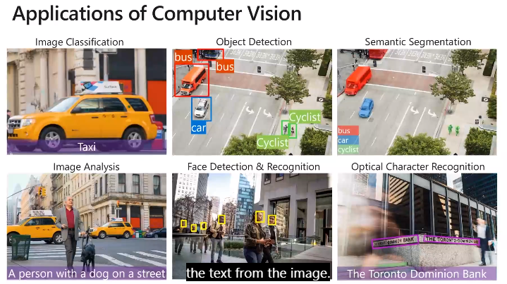

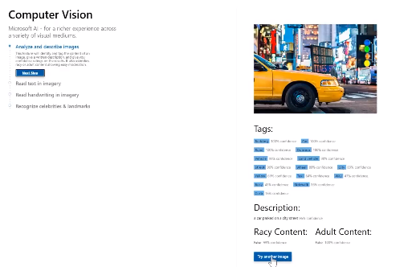

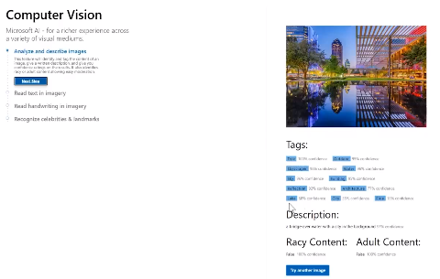

AI Algorithm giving information based on images

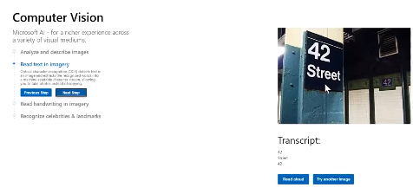

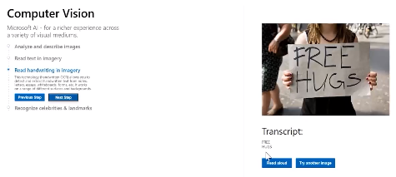

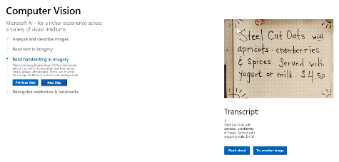

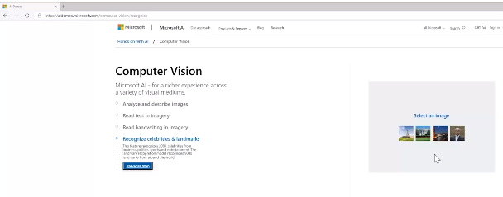

Recognises famous faces and places

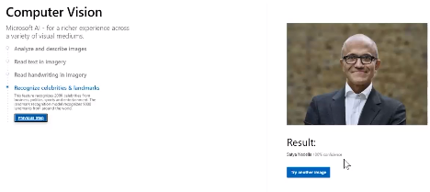

## Cognitive Services

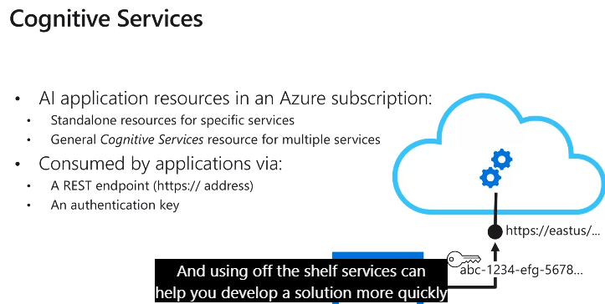

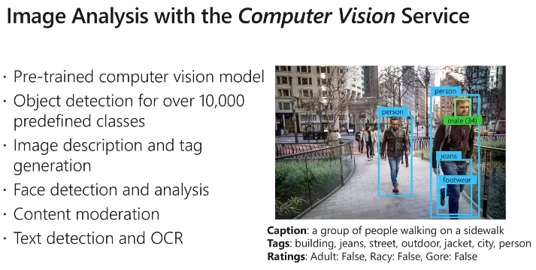

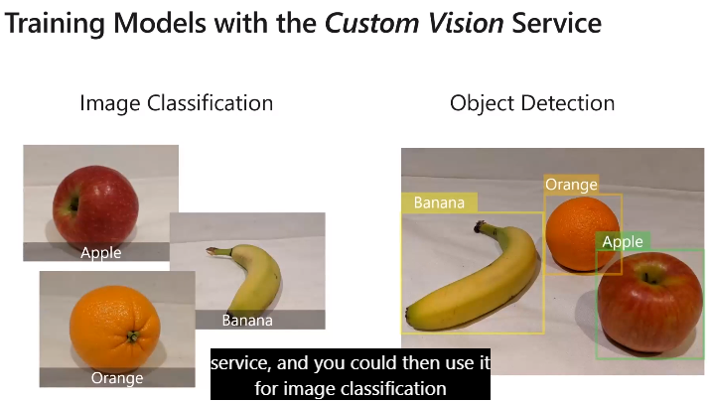

Can update existing, cand add your own images, etc.

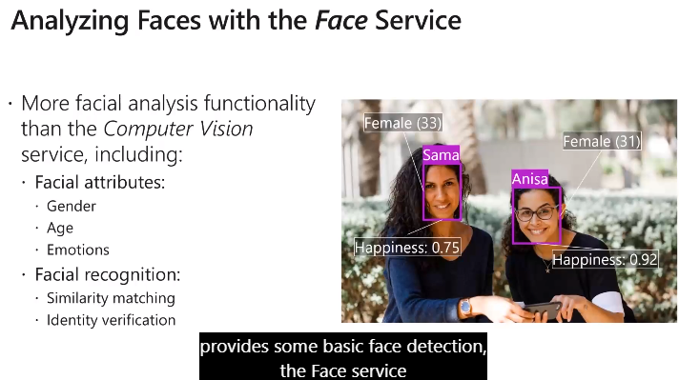

Can add to service for your own

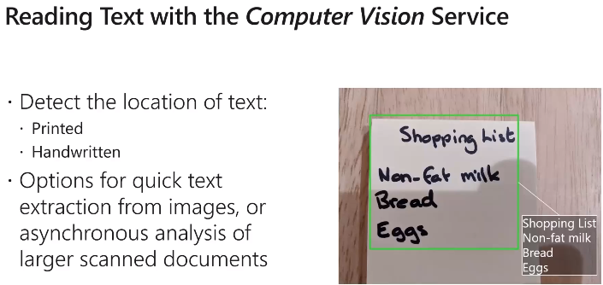

Provides multiple APIs to implement in an app

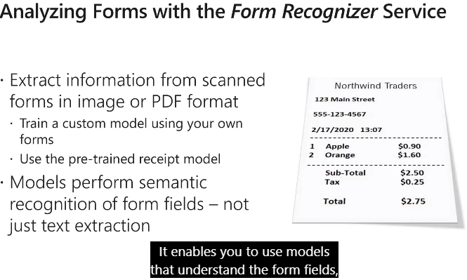

Can use to train your own model e.g. give it all your receipts

### Demo

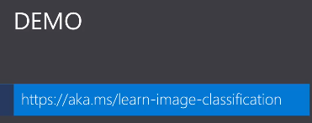

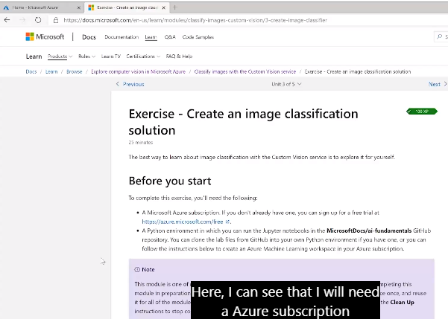

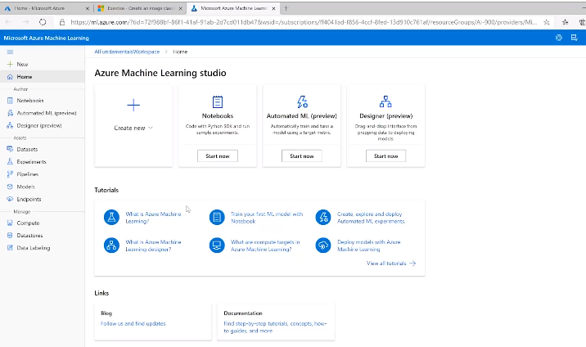

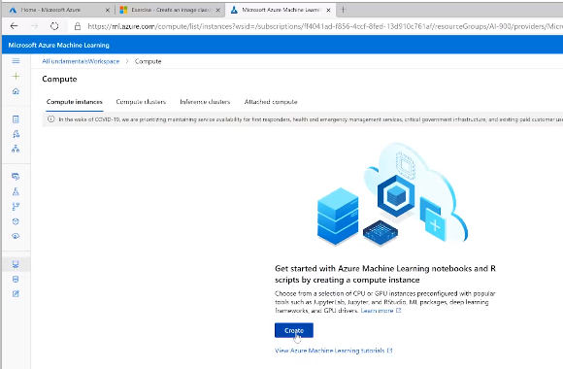

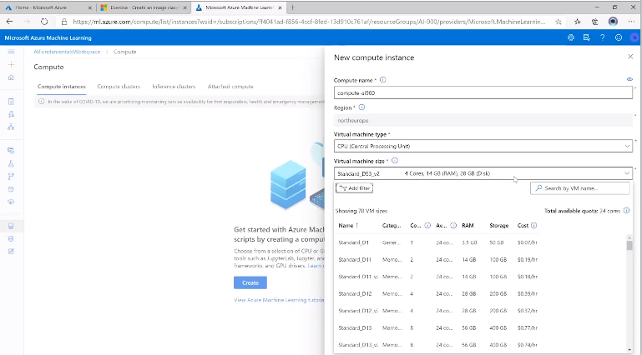

Spins up virtual machine that does all the compute for us

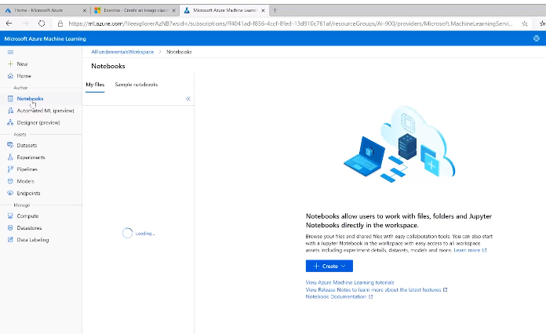

From MS Exercises but got too involved to follow/document how to add new images to train model.

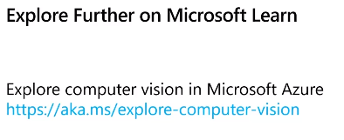

6 modules for learning how to do:

Images

Faces

Reading text

Form service

Etc

# Module 4 – Natural Language Processing

## NLP

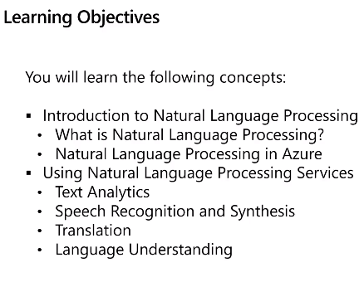

Computer Language = exact

Natural language = dialects, accents, wide vocabulary

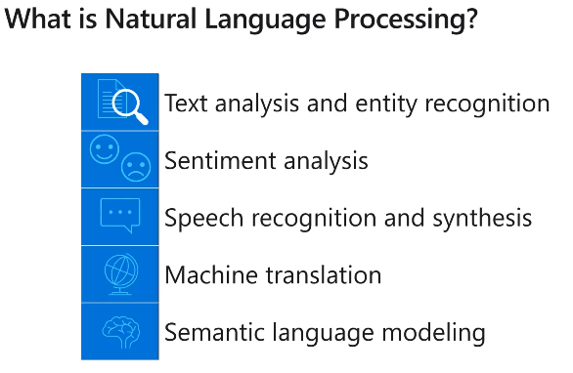

* Text & Entity – e.g. company checking when they are mentioned
* Sentiments – e.g. company check sentiment of mentions & reviews – how perceived positive/negative. E.g. twitter
* Speak and Synthesis – recognise spoken language. Read text messages to you and you can respond verbally
* Machine translation – translate to different languages – spoken then get response spoken/text in different language
* Semantic modelling – semantic understanding of the language being used to standardise meaning.

Models 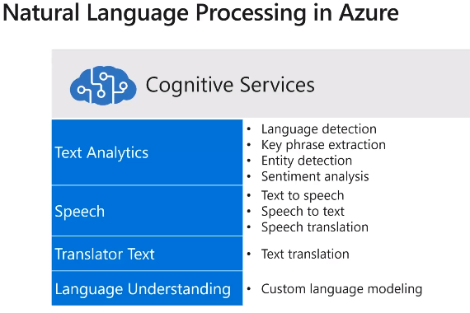

Can use your own models in for example Python.

Or can use Azure services as above

### Demo

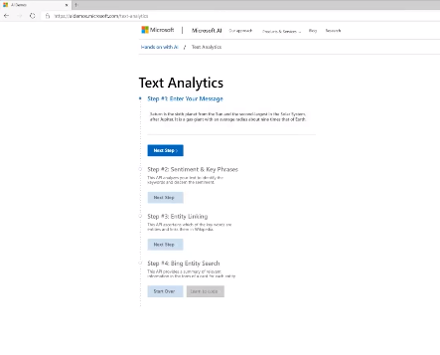

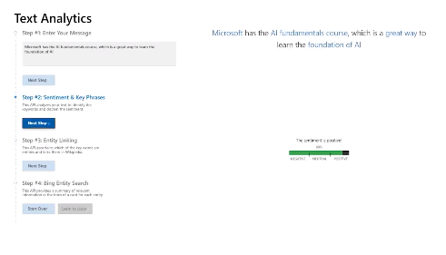

Can click buttons to do entity linking e.g. brings back AI in Wikipedia.

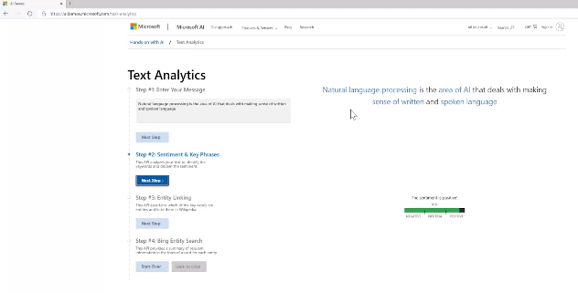

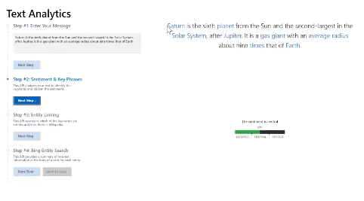

## Using Natural Language Processing Services

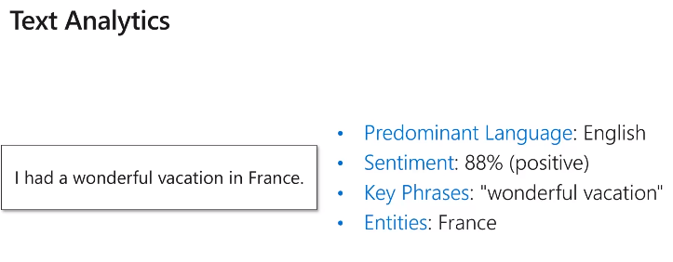

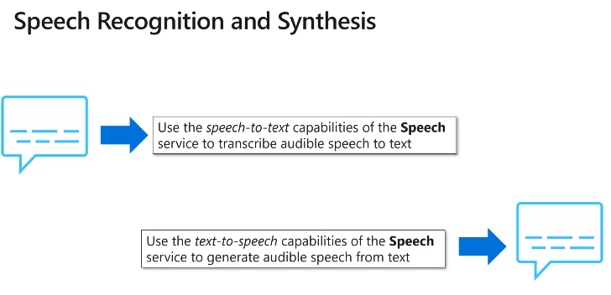

60 languages and has option to select regional accents to make more human

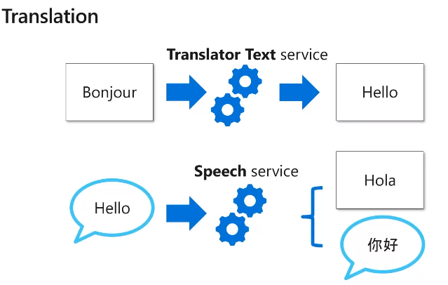

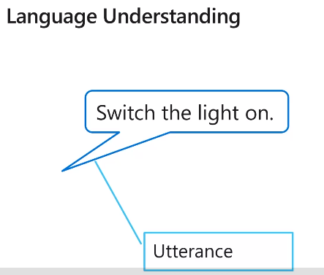

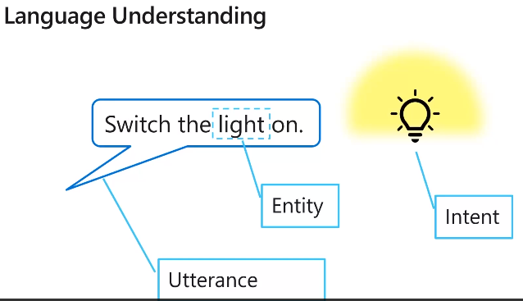

E.G. smart home stuff

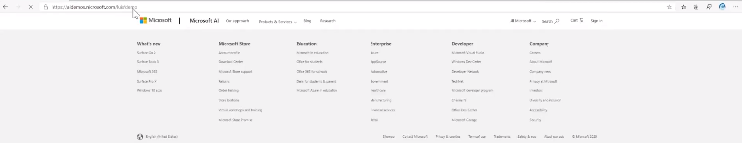

E.G. Call batman

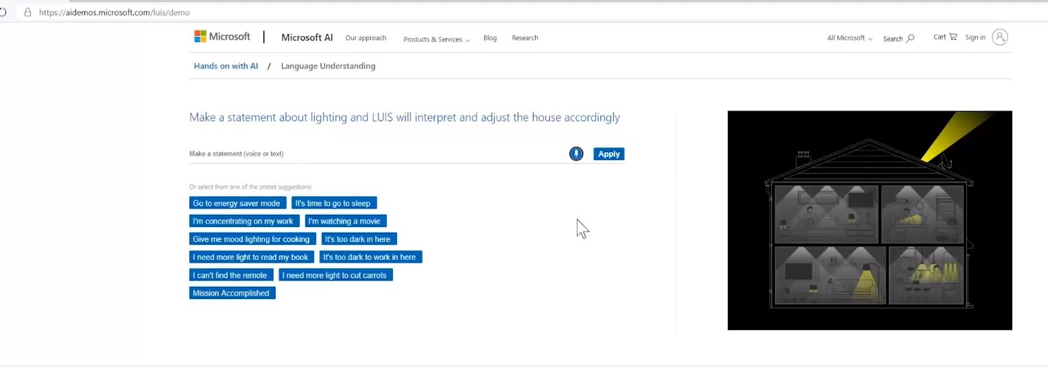

Exercise Language Understanding

Learn LUIS

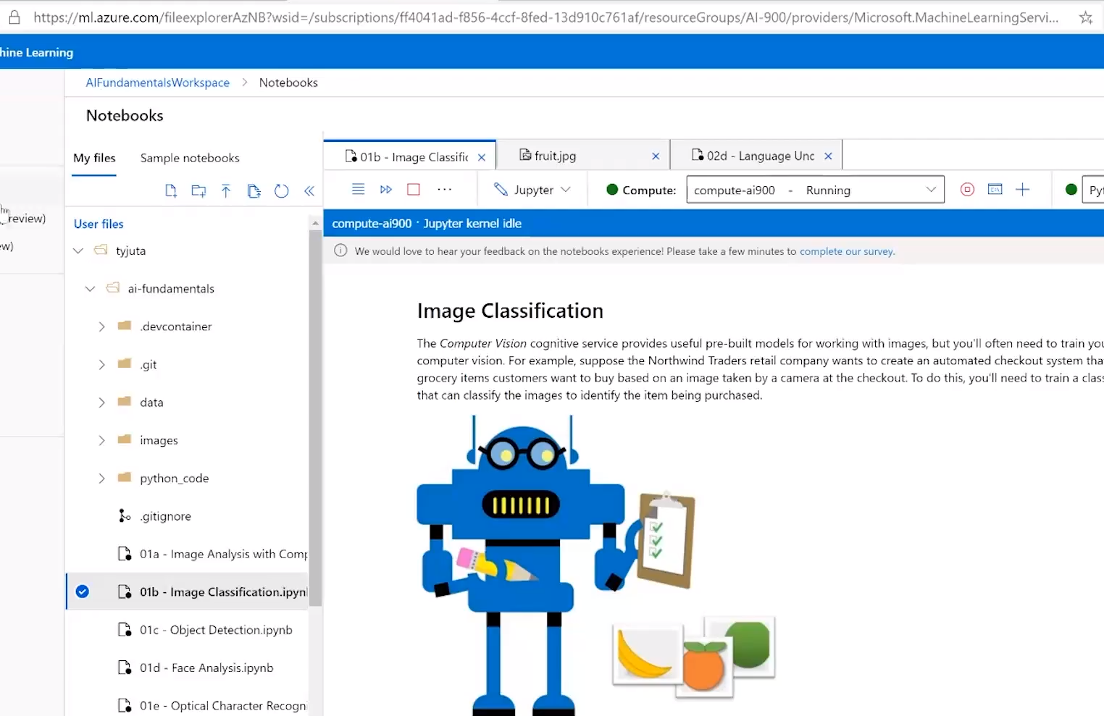

Setting up exercise as above – gets quite complex so not got all of this!

Need to setup files from GitLab and have enterprise license, subscription, etc

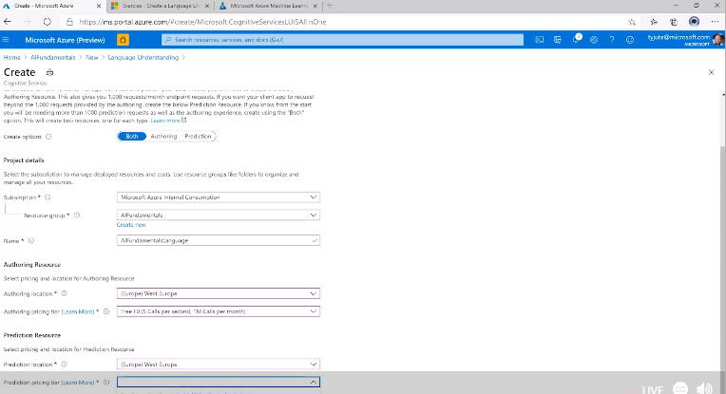

Add entities, intents and utterances

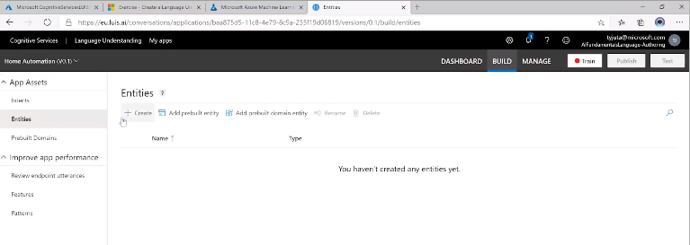

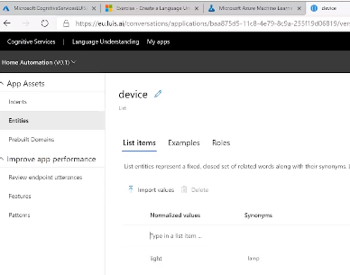

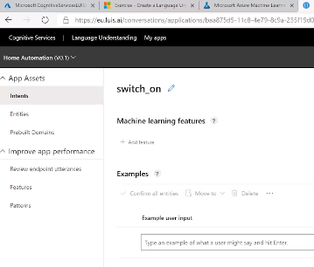

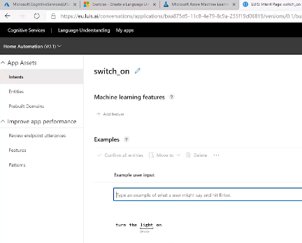

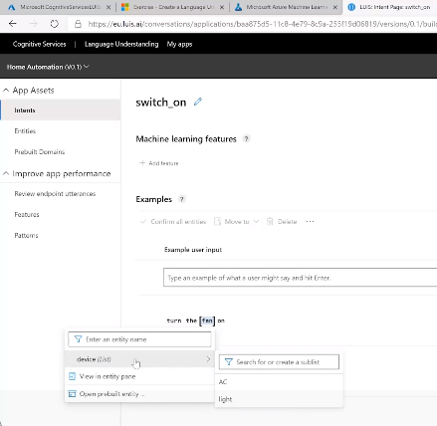

Then do the same for switching off

Then train and test model.

Train red button top RHS

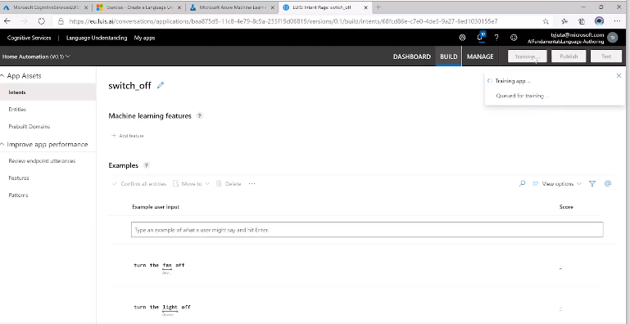

Test

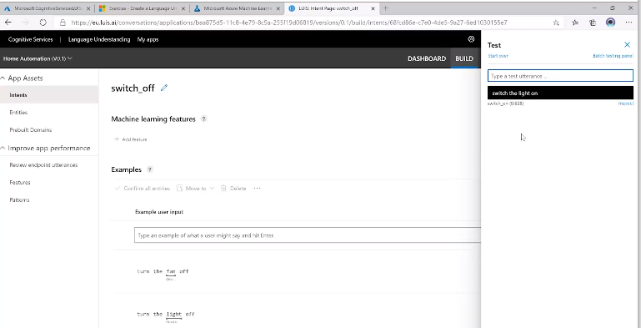

Publish Model and create end points

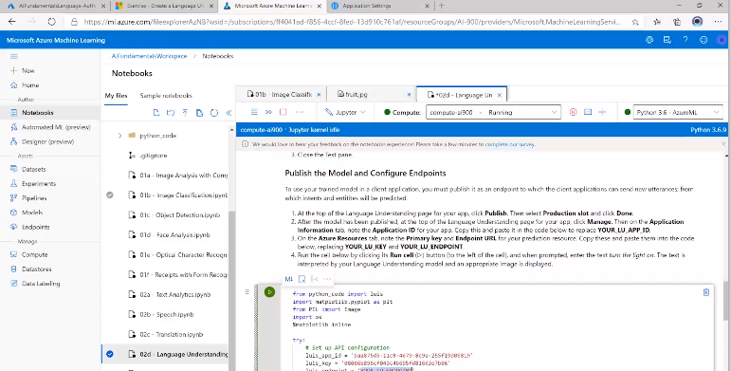

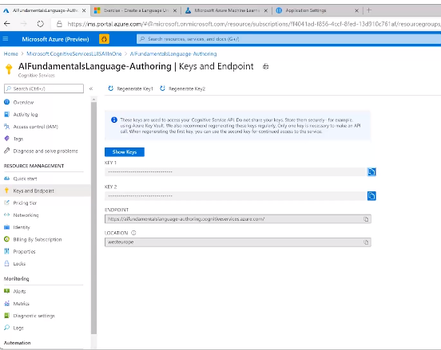

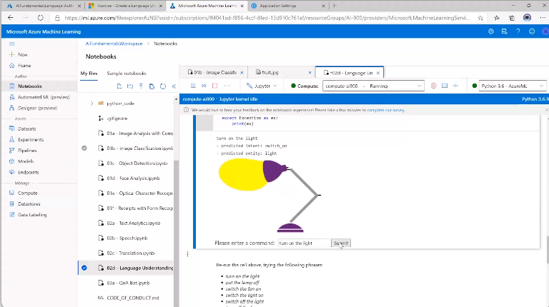

Trained it in the LUIS AI but can now use it in another application with the id and endpoint.

Can add voice control = cognitive service

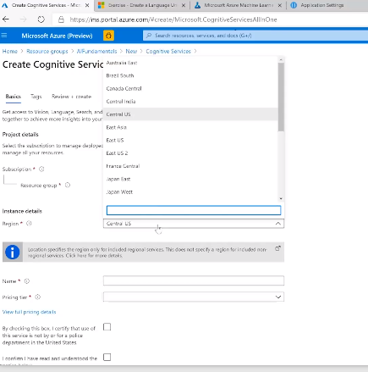

Use the languages exercises on MS Site.

# Module 5 – Conversational AI

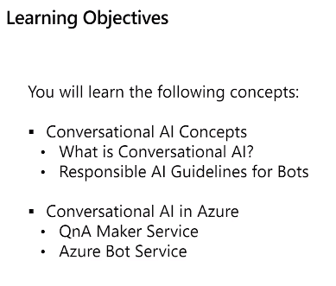

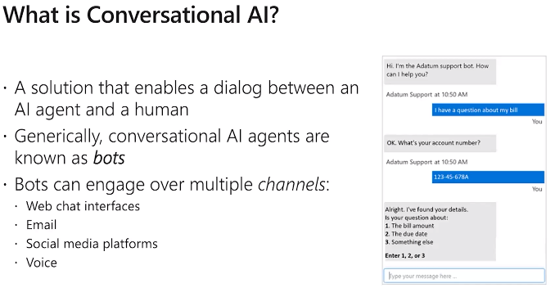

Cemo

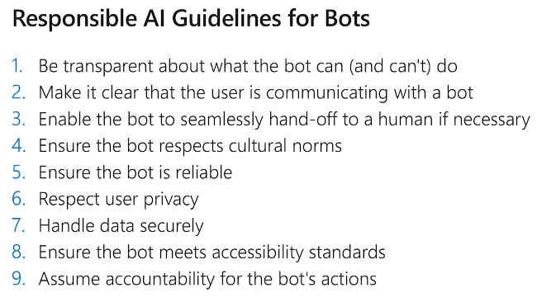

Demo

Bot Demo

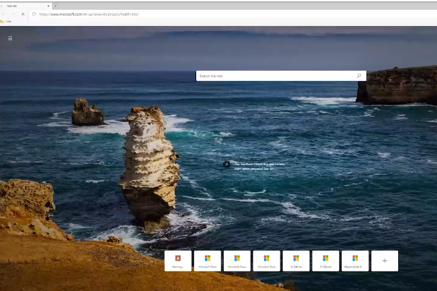

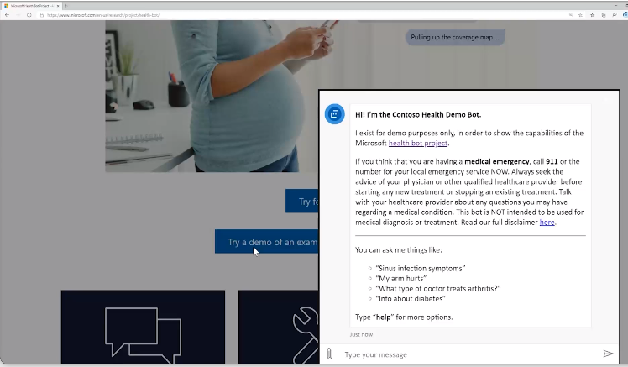

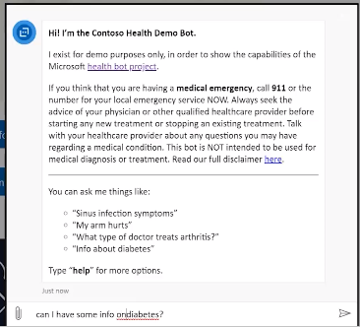

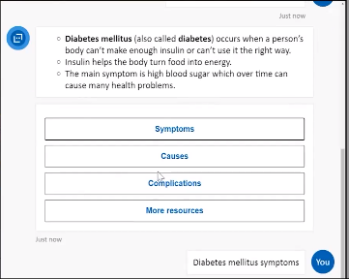

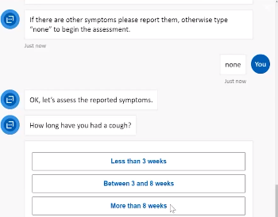

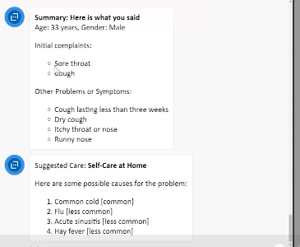

## Conversational AI in Azure

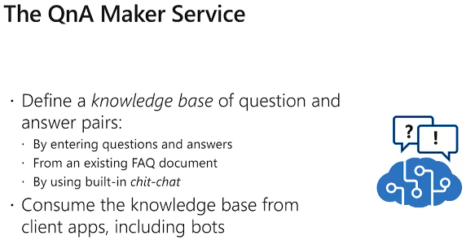

Train model on the Q&As and publish

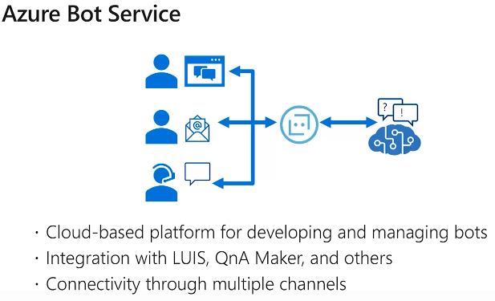

### Demo – Create Bot

Azure workspace and the notebooks

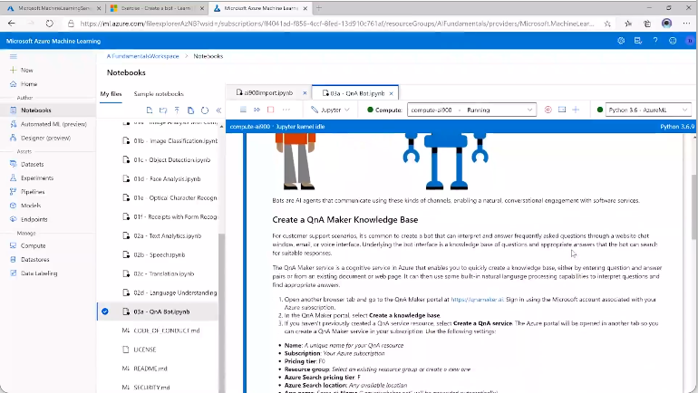

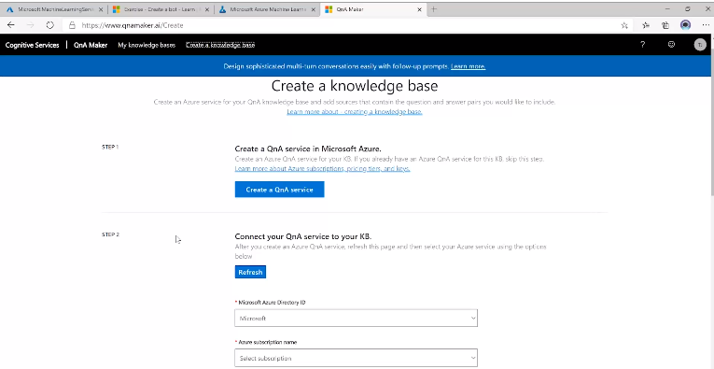

More setting everything up in the MS Exercises needing subscriptions etc.

So much missed/not understood.

Next save and train then test

Publish – which creates an end point can use in bot and portal

Next create an actionable bot

